Circle Language Spec: Globality

Globality in a Diagram
The principle of globality is explained in the article Globality. This article demonstrates its expression in a diagram.

A globality is displayed as a pentagon shape



Objects and commands can be placed inside the pentagon.

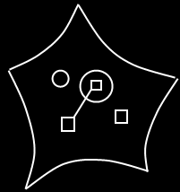

Access to global members happens in the diagram in the following way.

Definitions anywhere within the globality can access anything declared global. To make reference lines to global members more overviewable, imaginary intermediate references to the globality are added to all the mutual parents from which global things are accessed. See the article Automatic Containment for information about imaginary references and mutual parents.

The globality itself might not be in sight, when you are zoomed in on part of the globality. The solution is, that an imaginary reference to the globality is always displayed at the highest visible level of containment.

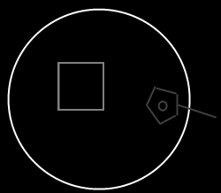

The imaginary reference to the globality displays all the global members of the globality. You can point to the global things you see inside this imaginary reference.

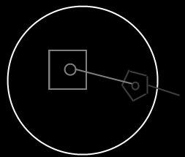

The imaginary references to globality are displayed as pentagons, that’s how you recognize it is global things you are accessing.

Here is a globality with a reference to another globality:

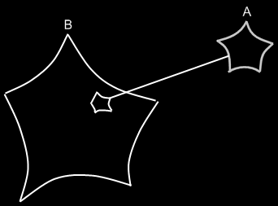

This makes all the global members of module A, globally accessible from inside module B.

